**CAPSTONE PROJECT REPORT**

(Project Term January-April, 2018)

## (Autonomous VoiceControl Car)

Submitted by

**(Niraj yadav ) Registration Number :11507443**

**(Subham malohtra) Registration Number :1150**

**) Registration Number :11510**

**Project Group Number:**

**Course Code:CSE339**

Under the Guidance of

**( )**

# School of Computer Science and Engineering



**DECLARATION**

We hereby declare that the project work entitled (“Title of the project”) is an authentic record of our own work carried out as requirements of Capstone Project for the award of B.Tech degree in Computer Science and engineering from Lovely Professional University, Phagwara, under the guidance of (Name of Faculty Mentor), during January to April 2016. All the information furnished in this capstone project report is based on our own intensive work and is genuine.

Project Group Number

Name of Student 1:

Registration Number:

Name of Student 2:

Registration Number:

Name of Student 3:

Registration Number:

Niraj Kumar

Date: 30-04-2018

Date: 30-04-2018

Date: 30-04-2018

**CERTIFICATE**

This is to certify that the declaration statement made by this group of students is correct to the best of my knowledge and belief. They have completed this Capstone Project under my guidance and supervision. The present work is the result of their original investigation, effort and study. No part of the work has ever been submitted for any other degree at any University. The Capstone Project is fit for the submission and partial fulfillment of the conditions for the award of B.Tech degree in Computer Science from Lovely Professional University, Phagwara.

**Signature and Name of the Mentor**

**Designation**

**School of Computer Science and Engineering,**

Lovely Professional University,

Phagwara, Punjab.

Date :

**ACKNOWLEDGEMENT**

Completing a task is never a one-man effort. It is the results of valuable contribution of a number of individuals in a direct or indirect manner that helps you shape and achieve an objective.

This project would not have taken shape, without the guidance provided by Mr. Pradeep kumar our Mentor, who helped us in our project and resolved all the technical problems and also helped in understanding technical aspects of the project. We profusely thank them for the support provided to us.

We also express a deep sense of gratitude for providing us the opportunity and trusting us for their project. We are very grateful.

**TABLE OF CONTENTS**

Inner first page……………………………………………………………………….(1)

Declaration…...……………………………………………………………………..(2)

Certificate……..…….………………………………………………………………(3)

Acknowledgement…………………...………………………………………….......(4)

Table of Contents……………………...……………………………………………(5)

**1. INTRODUCTION 6**

## 1.1. SECOND-LEVEL SUBHEADING 6

## 1.2. ANOTHER SECOND-LEVEL SUBHEADING 6

## 1.2.1. THIRD-LEVEL SUBHEADING 6

**1. INTRODUCTION**

The first-level subheading uses the formatting style Heading 1. It is centered, boldface, single line spaced, and it advances the text after it by two lines (24pt). No extra carriage returns are needed to correctly space the text that follows. First-level subheadings should be in all capital letters. You must capitalize the first-level subheadings yourself. MS Word can simulate Title Case capitalization but it will capitalize the first letter of EVERY word including articles and prepositions. First-level subheadings must not have more than a single blank line space before or after the heading.

## 1.1. SECOND-LEVEL SUBHEADING

This is the second-level subheading of the first section. The second-level subheading uses the formatting style Heading 2. It is left aligned, boldface and single spaced, and it advances the text after it by one line. Second level subheadings are in Title Case (The first letters of principal words must be capitalized).

## 1.2. ANOTHER SECOND-LEVEL SUBHEADING

The format of this subheading is the same with the first one. The purpose of this subheading is to show you that if you have a subheading of a certain level, you must have more than one. The rationale is that you cannot have a list of only one item.

### 1.2.1. THIRD-LEVEL SUBHEADING

The third-level subheading uses the formatting style Heading 3. It uses the same formatting with the second-level subheading except that for the third-level subheading, only the first letter of the first word and proper nouns are capitalized (Sentence case).

### 1.2.2. ANOTHER THIRD-LEVEL SUBHEADING

The heading above shows that if you have a subheading of a certain level, you must have more than one. The rationale is that you cannot have a list of only one item.

1. **Introduction**

**1.1 Objective of the project**

* This will be used as a spy gadget as to know where the enemies are and exact their location and their co-ordinates.
* This will be used as firefighting robot as get to know the real time situation with fire missions. And as from gas sensor it detects and can remove the fire from it
* Rescue proposals as in need with detection with civilians and other life forms. Gas detector can be connected to microcontroller and detect the lpg, cng and hydrogen gases.
* It is an all -terrain robot which can go to places where humans cannot so it can get the information which we cannot and it can detect thermal variation due to outsourced infrared sensor so it will be valuable for further projects too.
* It can detect human presence by infrared radiation.

**1.2 Description of the project**

**What is Arduino**

Arduino is an open-source electronics platform based on easy-to-use hardware and software. [Arduino boards](https://www.arduino.cc/en/Main/Products) are able to read inputs - light on a sensor, a finger on a button, or a Twitter message - and turn it into an output - activating a motor, turning on an LED, publishing something online. You can tell your board what to do by sending a set of instructions to the microcontroller on the board. To do so you use the [Arduino programming language](https://www.arduino.cc/en/Reference/HomePage) (based on [Wiring),](http://wiring.org.co/) and [the Arduino](https://www.arduino.cc/en/Main/Software) [Software (IDE),](https://www.arduino.cc/en/Main/Software) based on [Processing.](https://processing.org/)

Over the years Arduino has been the brain of thousands of projects, from everyday objects to complex scientific instruments. A worldwide community of makers - students, hobbyists, artists, programmers, and professionals - has gathered around this open-source platform, their contributions have added up to an incredible amount of [accessible knowledge](http://forum.arduino.cc/) that can be of great help to novices and experts alike.

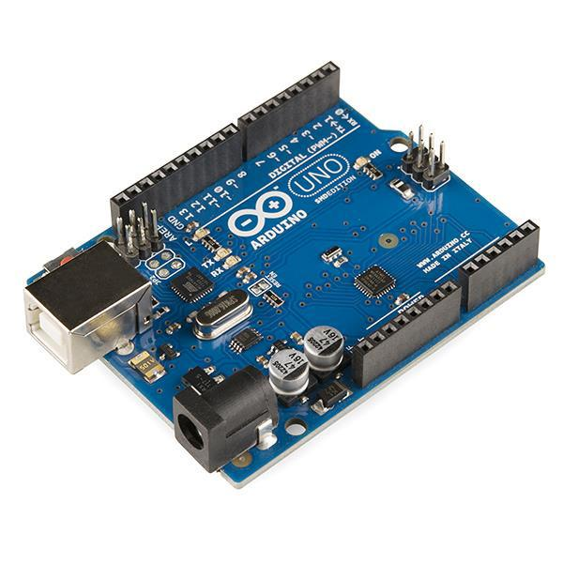

Arduino Analog and Digital pins contribution

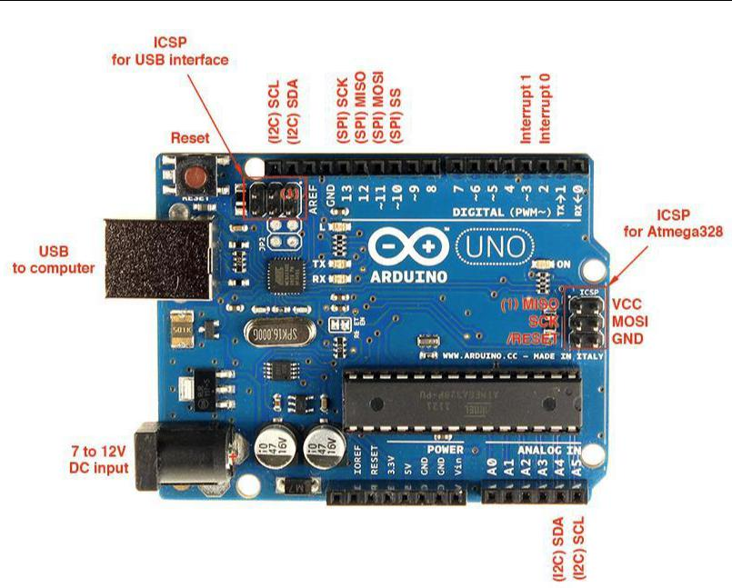

**Arduino**

Thanks to its simple and accessible user experience, Arduino has been used in thousands of different projects and applications. The Arduino software is easy-to-use for beginners, yet flexible enough for advanced users. It runs on Mac, Windows, and Linux. Teachers and students use it to build low cost scientific instruments, to prove chemistry and physics principles, or to get started with programming and robotics. Designers and architects build interactive prototypes, musicians and artists use it for installations and to experiment with new musical instruments. Makers, of course, use it to build many of the projects exhibited at the Maker Faire, for example. Arduino is a key tool to learn new things. Anyone - children, hobbyists, artists, programmers - can start tinkering just following the step by step instructions of a kit or sharing ideas online with other members of the Arduino community.

There are many other microcontrollers and microcontroller platforms available for physical computing. Parallax Basic Stamp, Net media’s BX-24, Phi gets, MIT's Handy board, and many others offer similar functionality. All of these tools take the messy details of microcontroller programming and wrap it up in an easy-to-use package. Arduino also simplifies the process of working with microcontrollers, but it offers some advantage for teachers, students, and interested amateurs over other systems:

* Inexpensive - Arduino boards are relatively inexpensive compared to other microcontroller platforms. The least expensive version of the Arduino module can be assembled by hand, and even the pre-assembled Arduino modules cost less than $50
* Cross-platform - The Arduino Software (IDE) runs on Windows, Macintosh OSX, and Linux operating systems. Most microcontroller systems are limited to Windows.
* Simple, clear programming environment - The Arduino Software (IDE) is easy-to-use for beginners, yet flexible enough for advanced users to take advantage of as well. For teachers, it's conveniently based on the Processing programming environment, so students learning to program in that environment will be familiar with how the Arduino IDE works.
* Open source and extensible software - The Arduino software is published as open source tools, available for extension by experienced programmers. The language can be expanded through C++ libraries, and people wanting to understand the technical details can make the leap from Arduino to the AVR C programming language on which it's based. Similarly, you can add AVR-C code directly into your Arduino programs if you want to.
* Open source and extensible hardware - The plans of the Arduino boards are published under a Creative Commons license, so experienced circuit designers can make their own version of the module, extending it and improving it. Even relatively inexperienced users can build the [breadboard version of the module](https://www.arduino.cc/en/Main/Standalone) in order to understand how it works and save money.

**How do I use Arduino**

See the [getting started guide.](https://www.arduino.cc/en/Guide/HomePage) If you are looking for inspiration you can find a great variety of Tutorials on [Arduino Project Hub.](https://create.arduino.cc/projecthub)

**Breadboard**

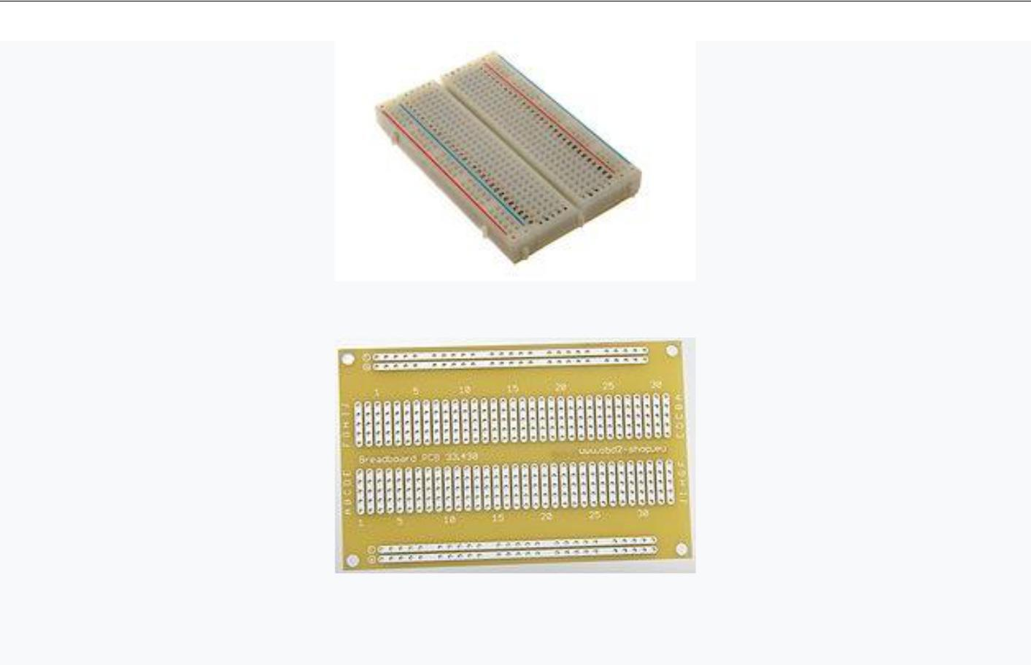

Solderless breadboard socket with 400 connection point Electrical equivalent [printed circuit board](https://en.wikipedia.org/wiki/Printed_circuit_board) (PCB) of the above solderless breadboard

A breadboard is a construction base for [prototyping](https://en.wikipedia.org/wiki/Prototype) of [electronics.](https://en.wikipedia.org/wiki/Electronic_circuit) Originally it was literally a bread board, a polished piece of wood used for slicing bread. In the 1970s the solderless breadboard (a.k.a. plugboard, a terminal array board) became available and nowadays the term "breadboard" is commonly used to refer to these.

Because the solderless breadboard does not require [soldering,](https://en.wikipedia.org/wiki/Soldering) it is reusable. This makes it easy to use for creating temporary prototypes and experimenting with circuit design. For this reason, solderless breadboards are also extremely popular with students and in technological education. Older breadboard types did not have this property. A [stripboard](https://en.wikipedia.org/wiki/Stripboard) [(Veroboard)](https://en.wikipedia.org/wiki/Veroboard) and similar prototyping [printed circuit](https://en.wikipedia.org/wiki/Printed_circuit_board) [boards,](https://en.wikipedia.org/wiki/Printed_circuit_board) which are used to build semi-permanent soldered prototypes or one-offs, cannot easily be reused. A variety of electronic systems may be prototyped by using breadboards, from small analog and digital circuits to complete [central](https://en.wikipedia.org/wiki/Central_processing_unit) [processing units](https://en.wikipedia.org/wiki/Central_processing_unit) (CPUs)

**GAS DETECTOR**

A gas detector is a device that detects the presence of [gases](https://en.wikipedia.org/wiki/Gas) in an area, often as part of a [safety system.](https://en.wikipedia.org/w/index.php?title=Safety_system&action=edit&redlink=1) This type of equipment is used to detect a [gas leak](https://en.wikipedia.org/wiki/Gas_leak) or other emissions and can interface with a [control system](https://en.wikipedia.org/wiki/Control_system) so a process can be automatically shut down. A gas detector can sound an alarm to operators in the area where the leak is occurring, giving them the opportunity to leave. This type of device is important because there are many gases that can be harmful to organic life, such as humans or animals.

Gas detectors can be used to detect [combustible,](https://en.wikipedia.org/wiki/Combustible) [flammable](https://en.wikipedia.org/wiki/Flammable) and [toxic](https://en.wikipedia.org/wiki/Toxic) gases, and [oxygen](https://en.wikipedia.org/wiki/Oxygen) depletion. This type of device is used widely in industry and can be found in locations, such as on oil rigs, to monitor manufacture processes and emerging technologies such as [photovoltaic.](https://en.wikipedia.org/wiki/Photovoltaic) They may be used in [firefighting.](https://en.wikipedia.org/wiki/Firefighting)

**ULTRASONIC SENSOR**

An Ultrasonic sensor is a device that can measure the distance to an object by using sound waves. It measures distance by sending out a sound wave at a specific frequency and listening for that sound wave to bounce back. By recording the elapsed time between the sound wave being generated and the sound wave bouncing back, it is possible to calculate the distance between the sonar sensor and the object.

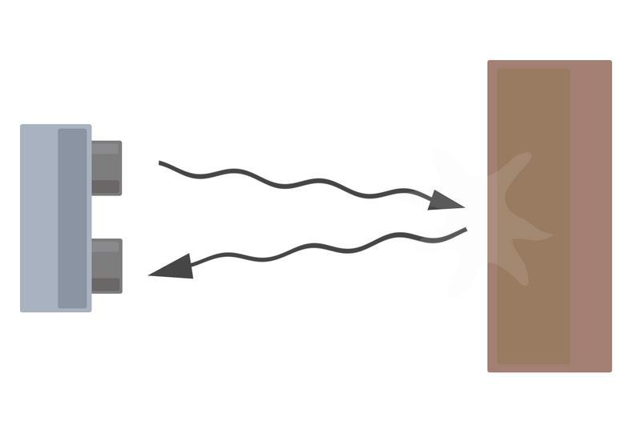

Diagram of the basic ultrasonic sensor operation

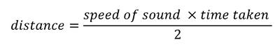

Since it is known that sound travels through air at about 344 m/s (1129 ft/s), you can take the time

for the sound wave to return and multiply it by 344 meters (or 1129 feet) to find the total round-trip distance of the sound wave. Round-trip means that the sound wave traveled 2 times the distance to the object before it was detected by the sensor; it includes the 'trip' from the sonar sensor to the object AND the 'trip' from the object to the Ultrasonic sensor (after the sound wave bounced off the object). To find the distance to the object, simply divide the round-trip distance in half.

**I R sensor**

Infrared waves are not visible to the human eye. In the electromagnetic spectrum, infrared radiation can be found between the visible and microwave regions. The infrared waves typically have wavelengths between 0.75 and 1000µm.

The wavelength region which ranges from 0.75 to 3µm is known as the near infrared regions. The region between 3 and 6µm is known as the mid-infrared and infrared radiation which has a wavelength greater higher than 6µm is known as far infrared.

Infrared technology finds applications in many everyday products. Televisions use an infrared detector to interpret the signals sent from a remote control. The key benefits of infrared sensors include their low power requirements, their simple circuitry and their portable features.

**The Foundations of Infrared Science**

Infrared radiation was first discovered by the astronomer William Herschel. He conducted an experiment in which he used a prism to refract light from the sun. Herschel was able to detect the presence of infrared radiation beyond the red part of the visible spectrum using a thermometer to measure an increase in temperature. In 1800 Herschel published his findings to the Royal Society of London

**The Types of Infrared Sensors**

Infrared sensors are broadly classified into two main types:

* Thermal infrared sensors – use infrared energy as heat. Their photo sensitivity is independent of the wavelength being detected. Thermal detectors do not require cooling but do have slow response times and low detection capabilities.
* Quantum infrared sensors – provide higher detection performance and faster response speed. Their photo sensitivity is dependent on wavelength. Quantum detectors have to be cooled in order to obtain accurate measurements.

**The Working Principle of Infrared Sensors**

All objects which have a temperature greater than absolute zero (0 Kelvin) possess thermal energy and are sources of infrared radiation as a result.

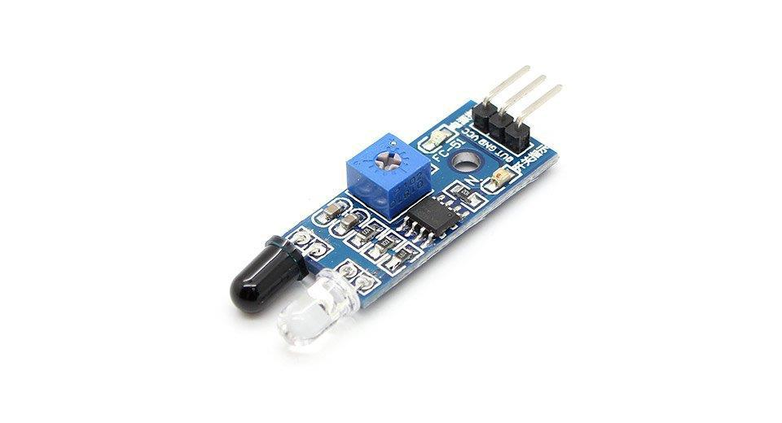Sources of infrared radiation include blackbody radiators, tungsten lamps and silicon carbide. Infrared sensors typically use infrared lasers and LEDs with specific infrared wavelengths as source

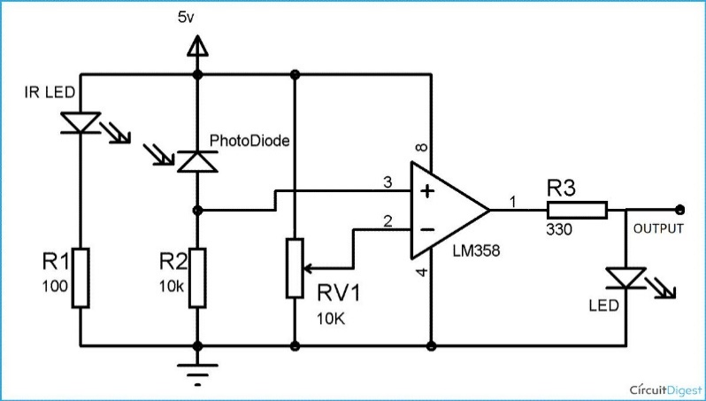**Circuit diagram**

**How to connect to Arduino**

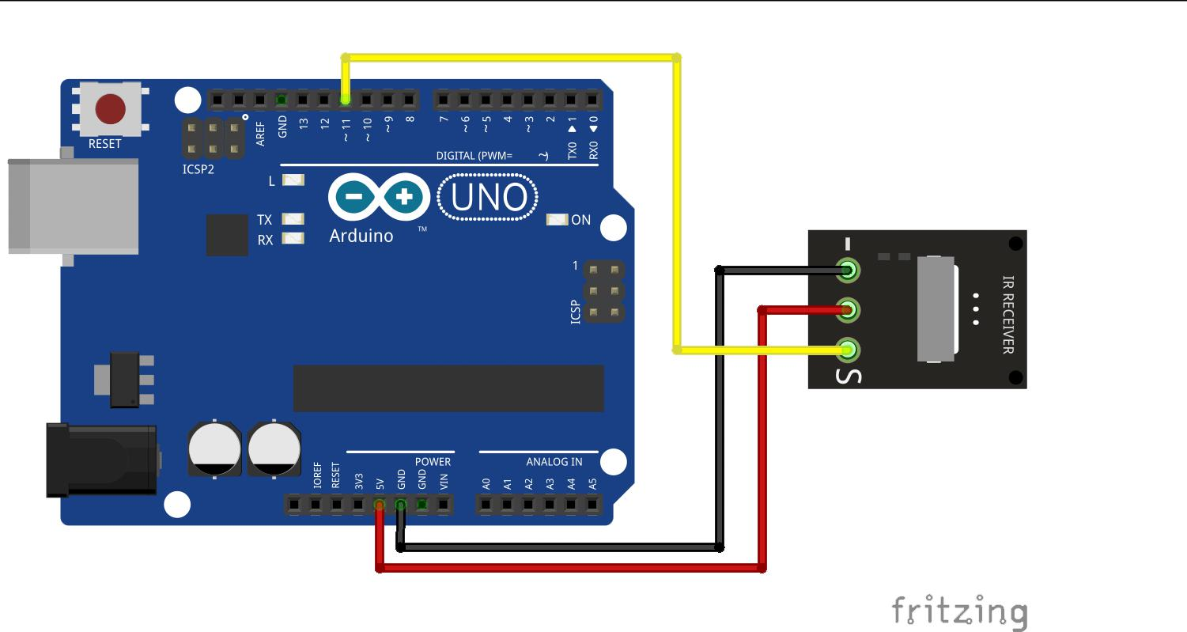

. **CHASSIS**

A chassis (pronounced TCHA-see or CHA-see) is the physical frame or structure of an automobile, an airplane, a desktop computer, or other multi-component device. Case is very similar in meaning but tends to connote the protective aspect of the frame rather than its structure. People tend to choose one term or the other. The rest of this definition uses chassis but applies as well to the term case. Both terms (and casing) are derived from the Vulgate Latin for box. The plural form is also chassis.

In a computer, the chassis houses the main electronic components, including the [motherboard](http://searchcio-midmarket.techtarget.com/definition/motherboard) (with places to insert or replace microchips for the main and possibly specialized processors and random access memory ( [RAM](http://searchmobilecomputing.techtarget.com/definition/RAM) ) and places for adding optional adapters (for example, for audio or video capabilities). Typically, room is provided for a [hard disk](http://searchstorage.techtarget.com/definition/hard-disk) drive and a [CD-ROM](http://searchcio-midmarket.techtarget.com/definition/CD-ROM) drive.

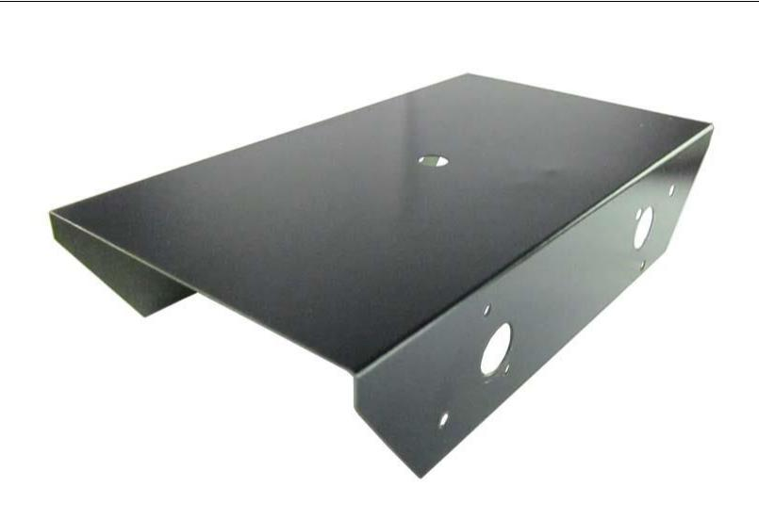



**Jump wire**

A jump wire (also known as jumper, jumper wire, jumper cable, [DuPont](https://en.wikipedia.org/wiki/DuPont) wire, or

DuPont cable – named for one manufacturer of them) is an [electrical wire](https://en.wikipedia.org/wiki/Electrical_wire) or group

of them in a cable with a connector or pin at each end (or sometimes without

them – simply "tinned"), which is normally used to interconnect the components of

a [breadboard](https://en.wikipedia.org/wiki/Breadboard) or other prototype or test circuit, internally or with other equipment

or components, without soldering.

Individual jump wires are fitted by inserting their "end connectors" into the slots provided in a breadboard, the [header connector](https://en.wikipedia.org/wiki/Pin_header#Header_connector) of a circuit board, or a piece of test equipment.

**Types**

There are different types of jumper wires. Some have the same type of [electrical](https://en.wikipedia.org/wiki/Electrical_connector) [connector](https://en.wikipedia.org/wiki/Electrical_connector) at both ends, while others have different connectors. Some common connectors are:

* Solid tips – are used to connect on/with a breadboard or female header connector. The arrangement of the elements and ease of insertion on a breadboard allows increasing the mounting density of both components and jump wires without fear of short-circuits. The jump wires vary in size and color to distinguish the different working signals.
* [Crocodile clips](https://en.wikipedia.org/wiki/Crocodile_clip) – are used, among other applications, to temporarily bridge sensors, buttons and other elements of prototypes with components or equipment that have arbitrary connectors, wires, [screw terminals,](https://en.wikipedia.org/wiki/Screw_terminal) etc.
* [Banana connectors](https://en.wikipedia.org/wiki/Banana_connector) – are commonly used on test equipment for DC and low-frequency AC signals.
* [Registered jack](https://en.wikipedia.org/wiki/Registered_jack) (Run) – are commonly used in telephone (RJ11) and computer networking (RJ45).
* [RCA connectors](https://en.wikipedia.org/wiki/RCA_connector) – are often used for audio, low-resolution composite video signals, or other low-frequency applications requiring a [shielded cable.](https://en.wikipedia.org/wiki/Shielded_cable)
* [RF connectors](https://en.wikipedia.org/wiki/RF_connector) – are used to carry [radio frequency](https://en.wikipedia.org/wiki/Radio_frequency) signals between circuits, test equipment, and antennas.

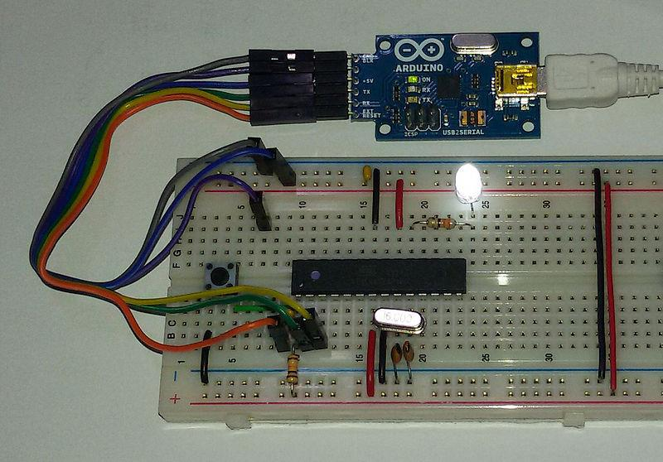

**Battery**

An electric battery is a device consisting of one or more [electrochemical cells](https://en.wikipedia.org/wiki/Electrochemical_cell) with external connections provided to power electrical devices suchas [flashlights,](https://en.wikipedia.org/wiki/Flashlight) [smartphones,](https://en.wikipedia.org/wiki/Smartphone) and [electric cars.](https://en.wikipedia.org/wiki/Electric_car)

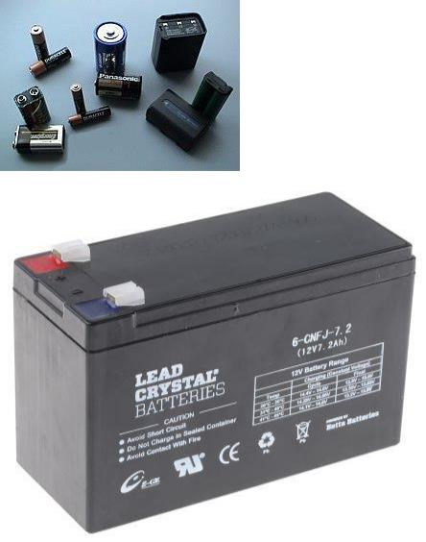[[1]](https://en.wikipedia.org/wiki/Battery_(electricity)#cite_note-1) When a battery issupplying [electric power,](https://en.wikipedia.org/wiki/Electric_power) its positive terminal is the [cathode](https://en.wikipedia.org/wiki/Cathode) and its negative terminal is the [anode.](https://en.wikipedia.org/wiki/Anode)[[2]](https://en.wikipedia.org/wiki/Battery_(electricity)#cite_note-Pauling1988-2) The terminal marked negative is the source of electrons that when connected to an external circuit will flow and deliver energy to an external device. When a battery is connected to an external circuit, [electrolytes](https://en.wikipedia.org/wiki/Electrolyte) are able to move as ions within, allowing the chemical reactions to be completed at the separate terminals and so deliver energy to the external circuit. It is the movement of those ions within the battery which allows current to flow out of the battery to perform work.[[3]](https://en.wikipedia.org/wiki/Battery_(electricity)#cite_note-3)Historically the term "battery" specifically referred to a device composed of multiple cells, however the usage has evolved additionally to include devices composed of a single cell

Here we use 9 v batteries and a joined 12-volt battery for input as a power source.

[**L293D Dual DC Motor Drive Module**](https://www.elechouse.com/elechouse/index.php?main_page=product_info&cPath=100_146&products_id=704)

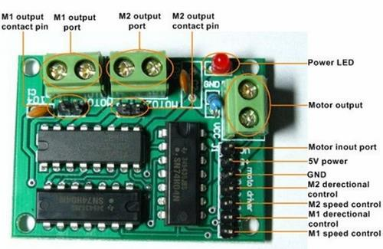

L293D is a typical Motor driver or Motor Driver IC which allows DC motor to drive on either direction. L293D is a 16-pin IC which can control a set of two DC motors simultaneously in any direction. It means that you can control two DC motor with a single L293D Cain a single L293D chip there are two h-Bridge circuit inside the IC which can rotate two dc motor independently-bridge is a circuit which allows the voltage to be flown in either direction-bridge IC are ideal for driving a DC motor. Due its size it is very much used in robotic application for controlling DC motors.

**Working of L293D**

There are 4 input pins for l293d, pin 2,7 on the left and pin 15 ,10 on the right as shown on the pin diagram. Left input pins will regulate the rotation of motor connected across left side and right input for motor on the right-hand side. The motors are rotated on the basis of the inputs provided across the input pins as LOGIC 0 or LOGIC 1. For rotating the motor in clockwise direction, the input pins have to be provided with Logic 1 and Logic 0. Enable pins 1 and 9 (corresponding to the two motors) must be high for motors to start operating. When an enable input is high, the associated driver gets enabled. As a result, the outputs become active and work in phase with their inputs. Similarly, when the enable input is low, that driver is disabled, and their outputs are off and in the high-impedance state.

**How to interface motors with L293D shield**

Hardware and Software Required

* L293D H-bridge Motor Driver Shield
* Arduino Uno
* DC motor(12V)
* Servo Motor
* Arduino IDE
* Hardware connections
* 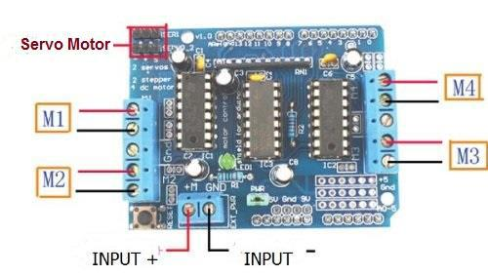Mount the L293D motor shield directly on the Arduino Uno and then connect the DC motor to M1 and servo motor to SER1 as shown in the image below:

**Program for L293D motor driver shield**

The user need to download and add this library file to the Arduino IDE which is attached [here:File:Adafruit-Motor-Shield-library.zip](https://wiki.eprolabs.com/index.php?title=File:Adafruit-Motor-Shield-library.zip) .

#include <AFMotor.h>

#include <Servo.h>

Servo myservo;

AF_DCMotor motor(1);//1 mean M1 in which the DC motor is connected

int pos = 0;

void setup() {

myservo.attach(9);//9 is the pwm pin

* turn on motor motor.setSpeed(200); motor.run(RELEASE);

}

void loop()

{

dc();

servo();

}

void dc()

{

int i;

motor.run(FORWARD);

for (i=0; i<255; i++)

{

motor.setSpeed(i);

delay(10);

}

for (i=255; i!=0; i--)

{

motor.setSpeed(i);

delay(10);

}

motor.run(BACKWARD);

for (i=0; i<255; i++)

{

motor.setSpeed(i);

delay(10);

}

for (i=255; i!=0; i--)

{

motor.setSpeed(i);

delay(10);

}

motor.run(RELEASE);



delay(1000);

}

void servo()

{

for(pos = 0; pos < 180; pos += 1)

{

myservo.write(pos);

delay(15);

}

for(pos = 180; pos>=1; pos-=1)

{

myservo.write(pos);

delay(15);

}

}

**Description**

as how it wil work as we have mentioned earlier it will work as a rescue robot

It will spy in that location where humans cannot go and may rescue them also.

We have use Arduino as microcontroller for controlling the whole operation here we have use the l2n3d module as a motor driving ice as it is used to operate the all motors to control it can be controlled by manual and automatic too.

We have used an ultrasonic sonar sensor for getting distance as at where distance the subject is and can be used as a

System description radar too

It can detect the subject in the dark too so it will much more useful in the military operation to detect the subject at night

Ire sensors are used as an obstacle detection and can detect its position and if anything come in front of it it will change its position expectedly

Chassis is used to hold the whole project and jumping wires to do he connection

And bred board to kept the connection to overruled

**2.3 Scope of the project**

As we have mention earlier it can be kept as operation in miler purposes and can be used as spy and rescue if further extended

If better materials and equipment and sensors are used it can be further used for much more better operations

For e.g. go on any terrain and can handle any atmosphere as gas detector can detect various gases to save many lives and rescue them

**2. System description**

**2.1 Customer /user profiles**

* To customer it is used as rescue operation
* To take the load operating for export and import operation
* To detect subjects in the dark and daylight
* To move paces where they cannot

**2.3 Functional requirements**

* It can be functioned as operation management to customers as well as military operation
* Functioned as searching operation
* Used as recue in fire rescue options
* To take data to further places
* To spy on others

**2.4 Nonfunctional requirement**

Chassis

It can be used a non-functional

As it can be further replaced by different materials to be used as much lighter as if the carbon fire be used it will be much more useful Arduino as it can be replaced as raspberry pi if we add much more stuffs to add so we can use this as a substitute Breadboard can be replaced by pcb to permanent soldering options.

3.**Design**

**3.1 System Design**

For the better understanding of the design of our project we have made the ER diagram in which we will show the attributes of each and every entity and DFD in which we will show the overview of our whole project.

**3.1.1 E-R diagram**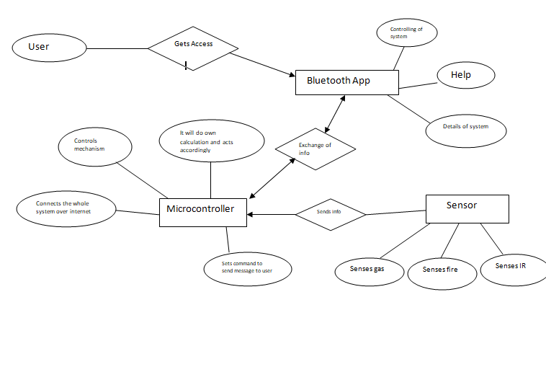

**3.1.2 DFD**

**CARCONTROL.png**

**4. Scheduling and Estimates**

|  |  |  |  |  |  |
| --- | --- | --- | --- | --- | --- |
| **Name** | **July** | **Aug** | **Sep** | **Oct** |  |
| **planning** | 25 july – 31 july |  |  |  |  |
| **Gathering of components** |  | 5 Aug – 20 Aug |  |  |  |
| **Assembing of components** |  | 22 Aug-28 Aug |  |  |  |
| **Coding of the system** |  |  | 1 Sep- 15 Sep |  |  |
| **Integrating with APP/WEB** |  |  | 16 Sep – 20 Sep |  |  |
| **MID TERM EXAM** |  |  | 21 Sep– 25 Sep |  |  |
| **Intergrating new features (extra features) it any** |  |  |  | 1 Oct-10 Oct |  |
| **Testing and maintenance of the system** |  |  |  | 11 Oct-22 Oct |  |
| **Writing the reports and etc** |  |  |  |  | Will be submitted by the end of first week. |
| **Submission of the project** |  |  |  |  |  |